Farm Woodland Assessment
forestry.gov.scot

Application Form 2026/27

Scottish Forestry is offering a limited number of free Farm Woodland Assessments to land owners and managers in central Scotland.

If you have considered integrating trees in to your farm business, the assessment can provide you with the information to make an informed decision. You can read about the benefits trees can bring to your farm business in our Why Trees? document.
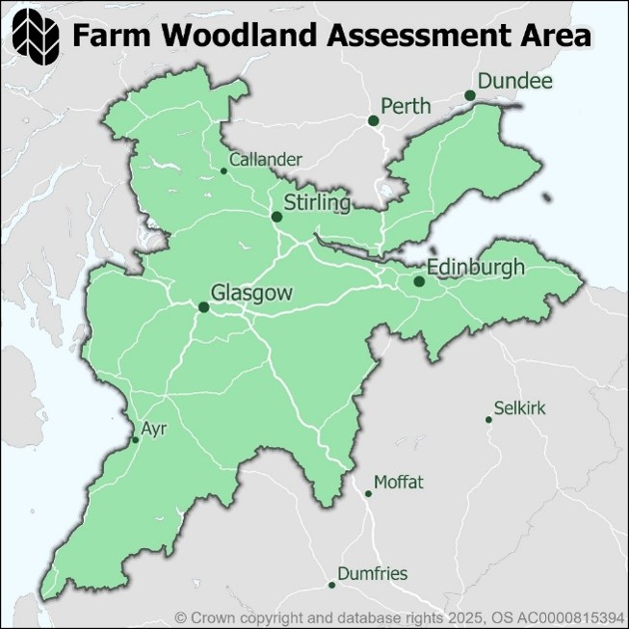
The assessment provides a report and maps identifying opportunities and constraints to planting, based on your objectives, and provides cost and grant budgets.

You must be within the Central Scotland Green Network, Forth Climate Forest or Fife Climate Forest (see map).

If you are interested in receiving a free Farm Woodland Assessment, please complete this form and return to: will.chadwick@forestry.gov.scot

Contact details

Contact Name | Click or tap here to enter text.
Address | Click or tap here to enter text.
Telephone | Click or tap here to enter text.
Email | Click or tap here to enter text.

Planting location

Farm Name | Click or tap here to enter text.
Farm Address | Click or tap here to enter text.
Farm Postcode | Click or tap here to enter text.
Grid Reference | Click or tap here to enter text.
Local Authority | Click or tap here to enter text.

Ownership details

Landowner | ☐
Tenant | ☐
Neither | ☐

If neither, what is your relationship to the landowner?
Click or tap here to enter text.

More about your farm business

What is your BRN? | Click or tap here to enter text.
What is your MLC? | Click or tap here to enter text.
What type of farm or farm business do you have? | Click or tap here to enter text.
What size is your farm? | Click or tap here to enter text. Ha
Do you have an IACS map? | Choose an item.
Why are you thinking about woodland creation? | Click or tap here to enter text.

Where are you considering planting

Have you idenfitied a site or location for planting? | Choose an item.
If yes, what is the area of land identified? | Click or tap here to enter text.Ha
Are there any known constraints to planting? | Choose an item.
If yes, please specify | Click or tap here to enter text.

Please return your completed form to will.chadwick@forestry.gov.scot.

The information within this form will be used to assess your applicability for the Farm Woodland Assessment only. It will not be used for any other purpose. If successful, you will be sent a Privacy Notice advising of how your data will be processed. If you are not successful, your information will be permanently erased.

Partner logo area

