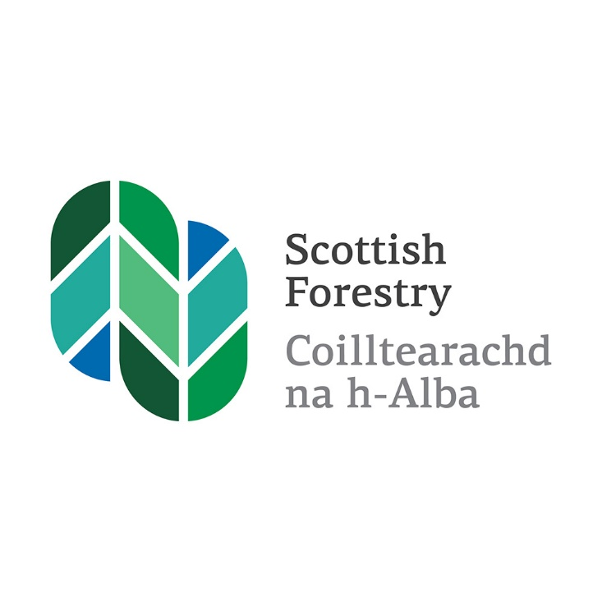

Scottish Forestry is the Scottish Government agency responsible

for forestry policy, support and regulation

Is e Coilltearachd na h-Alba a’ bhuidheann-ghnìomha aig Riaghaltas

na h-Alba a tha an urra ri poileasaidh, taic agus riaghladh do choilltearachd



An approach to prioritising control of rhododendron in Scotland

Contents

Executive Summary 3

Introduction 3

An approach to rhododendron control 4

Background 4

Objectives of this approach 5

Objective 1: Focus efforts on priority areas

Objective 2: Target entire local populations

Delivering control in priority areas 6

Financial support 7

Future steps 8

References 8

Appendix 1 – Why is rhododendron a problem for Scotland 9

1. **Executive Summary**

This approach to priotitising control of rhododendron in Scotland will help landowners demonstrate compliance with Scottich legislation on non-native species and reduce the impact of rhododendron in EU Natural Designated sites. Responsibility for the removal of invasive non-native species, such as rhododendron, rests with landowners.

The presence of rhododendron is a major cause of designated native woodlands being classified as in unfavorable condition. Therefore the underlying principle of this approach is to targer control in designated habitats, using synchronised action at a landscape scale, co-ordinated across multiple land holdings. To maximise value for money, Scottish Government funds should be targeted towards priority areas, where control focuses on entire populations of rhodoendron, and where best practice control measures are used.

1. **Introduction**

This document is aimed at supporting Scottish Government funding bodies, communities, landowners/managers and NGOs, who must decide on where and how funding is committed in order to achieve the successful control of rhododendron in priority habitats, and in the longer term, across Scotland.

There are many non-native species in Scotland, although only a small number of these cause damage to the environment, the ecomony, our health and in the way we live. These are called invasive non-native species. Responsibility for the removal of invasive non-native species, such as rhododenron, rests with landowners.

The presence of rhododneron is a major cause of biodiversity loss in Scotland, particularly on sites disignated under the Habitats Directive classified as in unfavourable condition, and in priority native woodland habitats such as Scotland’s rainforest. It was identified by the Scottish Forestry native woodland survey of Scotland as a contributing factor to woodlands being in poor condition.

In this document the problematic invasive wild type of Rhododendron ponticum and all its invasive hybrids are referred to simply as rhododendron.

Rhododendron is the host for two major plant pathogens, Phytophthora ramorumand Phytophthorakernoviae**,** that are both known to infect and kill trees. It also plays a significant role in the spread of these pathogens. Phytophthora ramorum is causing extensive damage and morality to larch trees and other plants in (mainly) the wetter west of Scotland. Removal of the host plant is considered to be an important element in the control of spread of these pathogens in Scotland and this will be a consideration when prioritising control of rhododendron-infected sites.

The underlying principle of the approach is to prioritise control of rhododendron where the greatest benefit to priority woodlands can be gained from synchronised control at a landscape scale and where action can be co-ordinated across multiple land holdings. Scottish Government funds will be targeted to these priority areas where control of entire populations of rhododendron is feasible and will be expected to follow best practice management techniques. Control of populations on non-priority areas will be considered for funding through the Forestry Grant Scheme, but the limitations of working at a site rather than landscape or population scale will to be recognised in the assessment of such applications.

Practical planning guidance titled “Guidance for delivering invasive non-native control projects” has been produced to support project officers and land managers when initiating and undertaking control projects. It is available on the Scottish Forestry web site.

1. **An approach to rhodoendron control**

Rhododendron is an invasive non-native species that was deliberately introduced to Scotland by humans and is out with its native range. This approach will help landowners demonstrate compliance with relevant legislation.

Responsibility for the remocal of invasive non-native species, such as invasive rhododendron, rests with landowners. It is an offence under the Wildlife and Counrtyside Act 1981, as amended to plant or cause to grow in the wild any plant out with its native range. This means that it is an offence to allow a non-native plant to spread into the wild. Landowners and occupiers are required to take reasonable steps and exercise due diligence to prevent rhodoendron from spreading into the wild. The code of good practice on non-native species made by Scottish Minsters under section14c of the Wildlife and Countryside Act 1981 sets out guidance on how you can act responsibly to ensure that non-native species under your ownership, care, and management do not cuase harm to our environment. Naturescot and Scottish Foresty have discretionary powers to require owners and occupiers to control invasive rhododendron on their land. Species control agreements can be offered under section 14D of the Wildlige and Countryside Act 1981 and if necessary followed by a Species control order.

The approach set out here also allows land managers to comply with the UK Forestry Standard guidelines on managing invasive species, particularly where collaborative actiosn are planned to control local populations of rhododendron.

1. **Background**

Introduced as a garden shrub in the 1800s, rhododenron is regarded as the most invasive and damaging non-native plant in the wild in Scotland (Williamson, 2002). The reasons why rhodoendron is a major problem in Scotland are summarised in Appendix 1.

Rhododenron ponticum thrives in the mild and wet conditions typical of the west of Scotland, and can tolerate a range of light levels from full sun to heavy shade. It thrives both in open spaces and closed canopy woodland and is known to live to over 100 years. If left untreated it can eliminate all vegetation growing beneath its conopy, and eventually out-compete nearly all native tree and shrub regeneration.

If rhododendron is left untreated, the potential scale and cost of its control will increase as populations continue to mature, expand and spread into new habitats (Edward and Taylor 2008). It has high seed output- a mature bush, can produce almost 1 million seeds annually – and the seed is very light and readily dispersed for short distances by wind. It can also be carried further afield on animal fur, clothing, vehicles and machinery.

The spread of rhododenron is a widespreadd issue and the impact of this invasive non-native plant on the habitats of Scotland is increasing in scale and extent, not least in Scotland’s rainforest. Information on the extent of rododendron in Scotland is available from several sources. The National Forest Inventory has published prliminary estimates of the prescence and extent of rhododendron in British Woodlands and is hosted on the Forest research web site. Information is also available for all native woodland habitants as part of the native woodland survey of Scotland. High level summary information of the condition of designated features on protected nature sites is available on the Scotland’s Environment web site. The data can be filtered and presented to show the pressurs affecting features and their current conditions status.

Evidince strongly suggests that some previous control projects have failed to provide the level of control required, because control areas were within re-seeding distance of untreated mature rhododendron populations, and that follow-up control was not sufficiently long-term in approach to ensure re-invasion of the control site did not occur.

1. **Objectives of this approach**

This approach has two objectives. These are consistent with the GB Invasive Non-native Species Strategy, the Scottish Biodiversity Strategy to 2045, and the Scottish plan for invasive non-native species surveillance, prevention and control.

Objective 1: Focus efforts on priority control areas

In 2017 a mapping exercise conducted by Scottish Forestry and NatureScot identified the highest priority woodlands for rhododendron control. These woodlands include those of the highest biodiversity value already affected by rhododendron, and/or vulnerable to invasion. Prioritising the removal of rhododendron from these areas will help native habitiats and associated features recover to favorable condition, which is a key requirement of the EU Habitiats Directive. A map of these priority woodlands can be viewed on the Scottish Forestry web site.

In addition, as set out in Objective 2, it is essential that control is done in a co-operative way at a population level across landholdings. A seris of landscape scale priority rainforest areas have emerged where there is local commitment and engagement to deliver control at a population level. These landscape scale areas are also priority areas for control. Further information and maps on priority rainforest areas can be found in the Scottish Government’s stratigic approach to restoring and expanding Scotland’s rainforest which can be viewed on the Scottish Forestry web site.

Objective 2: Target entire local populations

Learning from past experience has shown that co-operative working with coordinated activity at a population or landscape scale, is needed to effectively tackle thododendron, reduce the potential for spread into non-infected areas, achieve long-term control and aviod continued funding control operations (Harris et al 2002).

An entire local populationis defined as one or more core areas of mature flowering bushes, usually densely populated, plus a surrounding 500m bush-free buffer zone, i.e. the area out with which seedlings are unlikely to establish. In some environments populations are linear in nature, and can extend for several lkilometres e.g. along lochside edges, where it may be necessary to increase this buffer. In all cases there needs to be a demonstration of the feasibility of populaton control, ability to co-ordinate long term delivery and strong engagement and supprot from communities and landowners/managers.

The supplementary guidance for delivering invasive non-native plant control projects

explains further the metholodgy for landscape scale control of entire local populations.

1. **Delivering Control Priority Areas**

As the lead public bodies for rhododendron control, Scottish Forestry and NatureScot will work together on behoalf of Scottish Government to support the control of rhododenron in priority areas. However this cannot be achieved withour the suppport and commitment of other organisations, communities, landowners and individuals. Projects will only be funded if they use the most appropriate control methods for that particular infestation and location.

To support delivery Scottish Forestry and NatureScot will:

* Support the Alliance for Scotland’s Rainforest in raising awareness across Scotland’s land management, communitiy, non-government organisations and the wider public, of the problem of rhododendron and the approach to prioritising and controlling it;
* Work with a range of partners, stakeholders to embed this approach, encouraging them to inform and motivate others, provide opportunities for learning and skill-sharing among practitioners, and support work to develoop the contracor base in Scotland;
* Focus efforts on promoting effective control work in priority areas, encouraging landowners and project coordinators to be champions within their communities;
* Ensure this approach is embedded on the National Estate and other land managed by Scottish Governement on behalf of the people of Scotland;
* Provide clear and consistent advice on complying with relevant legislation;
* Implement a proportionate and risk-based approach to using species control agreements and orders where this is needed to achieve effective population control;
* Support continued work to increase our knowledges about the risks posed by rhododendron and research into control methods, so that control efforts are as effective as possible.

The likely roles and responsibilities of others – funders, project co-ordinators, landowners, volunteers, and other public bodies- are outlined in the implementation guide that accompanies this approach.

1. **Financial Support**

Rhododendron control is currently funded through the Foresrty Grant Scheme (FGS), the Nature Restoration Fund ( NRF) and the Agri-Environment Climate Scheme. Funding is available through NRF for project development including engagement and survey.

Funding will be targeted to supporting landscape scale control projects in priorty areas. Applications for areas out with the prioroty areas will need to make a stong case for being funded (including a letter of support from NatureScot). These exceptional cases would include other designated sites that are in unfavourable condition because of rhododendron; or where rhododendron control is needed to maintain favourable condition; or to follow up previous control in priority habitats. However the limitations of working at site rather than landscape scale need to be recognised.

When assesing applications for rhododendron control the following should be considered;

* Is there deomonstration of co-ordinate delivery at a landscape scale?
* Is there demonstration of stron support for action amongst local communities, landowners and crofters and delivery partners including Forestry and Land Scotland (FLS)?
* Is there a managable number of participating owners, tenants, crofters and householders to ensure activity can be co-ordinated and delivered?
* Does the project encompass an entire local population that is manageable to control? This data can be found from site visits and datasets such as the Native Woodland Survey of Scotland.
* Are local physical conditions conductive to rhododendron spread? For example near to a seed source (including private gardens), which is upwind/upstream?
* Will the project benefit or help protect a Special Area of Conservation, Site of Specific Scientific Interest, important areas of rainforest woodland, or imortatant plant areas? These areas are registered on the NatureScot sitelink map.
* Will it use the most appropriate control methods and be ables to secure on-going control and commitments in the area?

In 2021 the Alliance for Scotland’s rain forest estimated a cost of £234M to control rhodendron over the whole rainforest zone. Given the scale of the invasive rhodoendron problem, it is likely that there will only be resources available to treat some of the priority sites each year, therefore a phased approach is needed and to ensure value for money is achieved. This approach prioritises projects that demonstrate the ability to deliver co-ordinated and sustained landscape scale control on priority areas where it will have a lasting benefit. Additionally monitoring and follow up control must be maintained until local eradication is achieved.

There is potential for rhodoendron control to be funded by other public and private sources, including natural capital finance, and ideally this will be blended with Scottish Governments funding to focus on these priority areas.

1. **Future Steps**

It is anticipated that future steps will be;

* In the short term (0-5 years) to disseminate best practice information on currently successful rhodoendron control prohects; and to use the principles behind this approach for controlling other invasive non-native species.
* In the medium ternm (5-10 years) to secure commitment and resources for the longer term and review the technical knowlegde underpinning this approach.

1. **References**

Edwards, C. 2006

Managing and controlling invasive rhododenron.

Forestry Commision Practice Guide, Forestry Commision, Edinburgh.

Ewards, C & Taylor, S. 2008

Rhodoendron control costs and priorities.

Technical seminar, June 2008 Forest Research, Edinburgh.

Harris, C, M, Park, K, J, Atkinson, R, Edwards, C and Travis, J, M, J. 2009. Invasive species contorl: incorporating demographic data and seed dispersalinto a management model for Rhodoendron ponticum.

Ecological Informatices, doi: 10.1016/j.ecoinf 2009.07.005.

Willimson, M, 2002

Alien plants in the British Isles. In: Pimental, D (Ed.) Biological invasions. CRC Press London.

Parrott, J & MacKenzie NA 2013. A critical review of work undertaken to control invasive rhododenron in Scotland.

Scottish Foresty 2017 Guidance for delivering invasive non-native plant control projects.

**Appendix 1**

Why is rhododendron a problem for Scotland?

It damages the enviroment

Rhododendron reduces the biodivestity of woodlands, open ground habitats and water courses. Once establishedm it casts dense shade and produces poor quality leaf litter, impacting on water quality and reducing inverebreae abundance. In turn this affects fish. Amphibian and bird populations. The dense shade will eventually eliminate all ground flora and prvent it from returning.

It can invade peatlands, particularly raised bogs already damaged by drainage, and prevents the vital accumulation of organic matter which forms peat.

Rhododendron is present on many protected natue sites (such as Sites of Special Scientific Interest and Special Areas of Conservation), and some fail to meet their site condition standards as a consequence.

The process of rhododendron displacing native species and modifying habitats is particularly acute in rare and sensitive habitats suxh as the Atlantic woodlands of oak, hazel and birch on the west coast of Scotland.

The Impact of rhododendron on Scotland’s Rainforest

Scotland’s Atlantic Rainforest, is make uyp of iconic and internationally important woodlands which depend on the clean air and mild, moist, ocenic climat of Scotland’s western seaboard – making thme a cool temperate version of tropical rainforests. They support a unque flora of lichens, osses and liverwortswhich are amongst the richest on the planet, and some of which are extremely rare.

The Alliance for Scotland’s Rainforest (ASR) has defined Scotland’s rainforest as any native woodland within the “hyper-oceanic” zone of the west coast of Scotland based on precipitation and temperaure range and where the woodlands are very rich in oceanic bryophtes and lichens.

Plant life and their partners have identified the west coast of Scotland as an Important Plant Area (IPA), containing 80 Sites of Scientific Interest, 13 Special Areas of Conservation and 5 National Nature Reserves. However, the spread of rhododenron into its woodlands, wet heaths and rocky slopes is a serious threat to this internationally important area. Even after rhododendron clearance by the most sensitive methods, re-colonisation by the rarer species is extremly slow.

It damages livelyhoods

Dense stands of rhodoendron lower the amenity and recreation value of wiidlands, restrict access to the countryside, block path networks and make riverbvanks inaccessible for angling.

Rhododendron foliage contains andromedotoxin which is poisonous to mammals if ingested. Therefore established plants cannot be controlled by grazing, and it has no value as fodder. Equally, invasion by rhodoendron makes land unsuitable for grazing, significantly reducing the vale of grazing land where is tis found.

In commercial foresrty plantations, rhododenron suppresses the growth of trees and impedes harvesting and restoking operations, leading to increased managemnt costs.

It Harbours plant diseases

Rhodoendron host two known strains of Phytophthora. These pathogens affect a number of shrub and tree species used in commercial forestry, nurseries and horticulture buisnesses as well as those found in private gardens and designated sites. It has a particularly severe impact on larch plantations buth there is no known treatment for it.

It spreads quickly

The pernicuous growth of rhodorndron in Scotland means that the costs of controlling it will continue to rise. It is estimated that over £10 milliion was spent on rhododendron control in Scotland from 2003 to 2013, and yet it continues to spread.