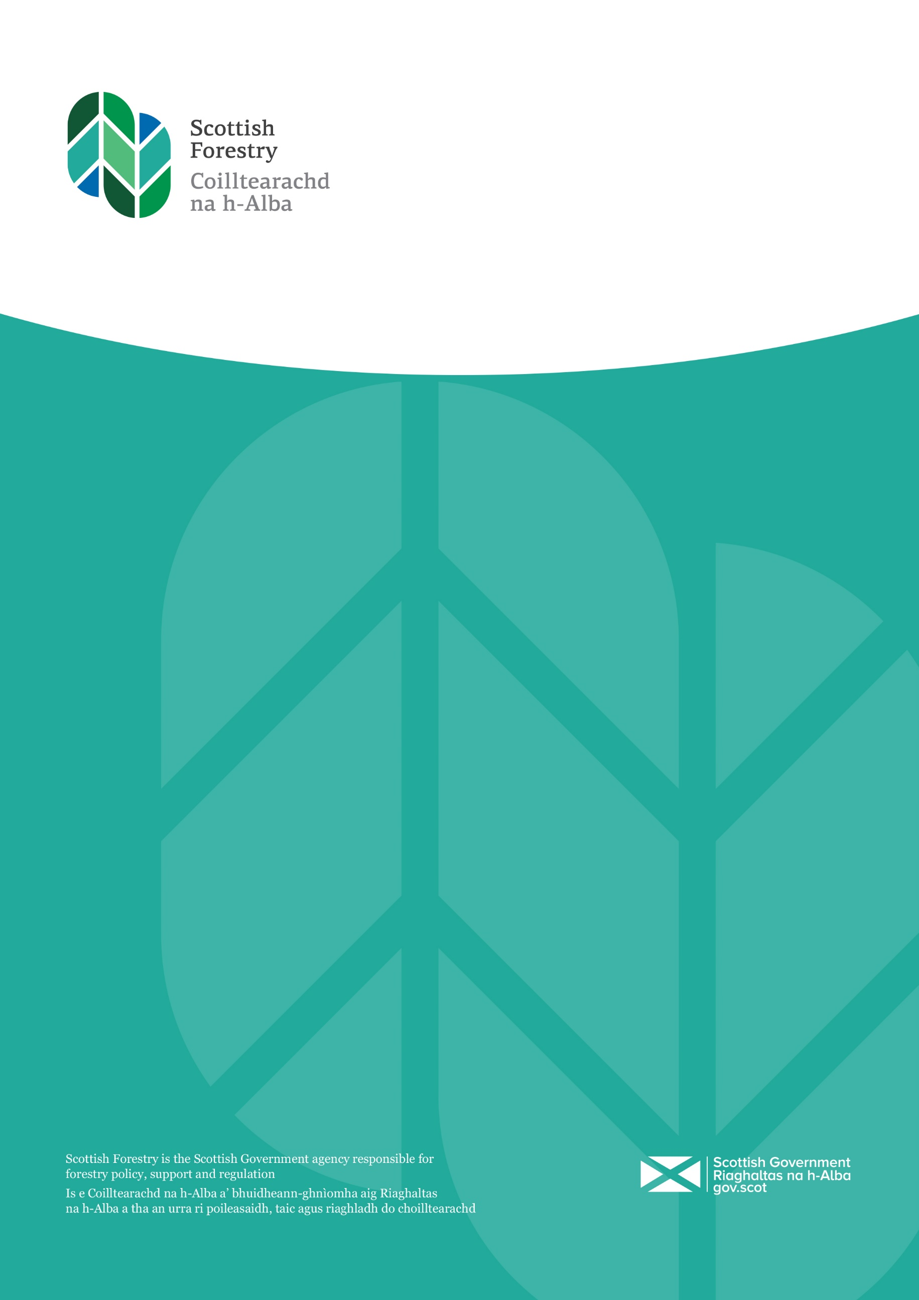

2021/22 Statement on Sustainable Economic Growth

Introduction

This is the third Statement on Sustainable Economic Growth since forestry became fully devolved to Scotland and Scottish Forestry became a new Scottish Government agency. Our role today involves helping Scottish Ministers develop forestry policy, supporting the sector and the regulation of forestry activities and builds on a century of excellence and professionalism under the auspices of the Forestry Commission.

Statement

The Forestry Grant Scheme (FGS) is in its seventh year; interest in planting new woodland remains strong.  Submitted applications to the scheme now have a combined value of nearly £352 million, of which £320 million have received their grant contract.  These applications will create 73,123 hectares of new woodland (66,008 hectares have received their contracts), as well as providing support for the management of existing forests.

Around 64 percent (6,337ha) of FGS supported woodland creation in 2021/22 was planted as productive woodland specifically aimed at growing sustainable timber, and 44 percent (4,362ha) of FGS supported woodland was planted with native trees.  This activity makes a significant contribution to the rural economy, with the forestry sector as a whole supporting over 25,000 jobs and producing over £1 billion of Gross Value Added.

The total area of new woodland planted across Scotland in 2021/22 was 10,480 hectares, which shows Scotland was responsible for 75% of all new woodland creation last year.  Being one of very few industries with a net carbon reduction, each year Scotland’s tree planting efforts make a critical contribution to responding to the global climate emergency, removing 7.6 million tonnes of CO2 from the atmosphere annually (Quantifying the Sustainable Forestry Carbon Cycle: 2022).

We continue to safeguard the ability of Scotland’s forests and woodlands to provide a wide range of benefits for current and future generations. Given the degree of uncertainty about future environmental, ecological, economic and social conditions, relative to the lifespan of our trees, our approach will continue to support and enable improvements to the adaptability and resilience of Scotland’s forests and woodlands.

Scottish Forestry continues to improve the understanding of current and potential threats to Scotland’s forests and woodlands and ways to reduce or manage the threats through contingency planning, research and development of new technologies.

We manage the threats and spread of existing pests and diseases through surveillance, monitoring, control actions both statutory and non-statutory, biosecurity measures and education

We continued to allocate The Strategic Timber Transport Fund to projects that minimise the impacts of timber transport on communities and the environment by reducing road miles and improving rural road infrastructure. In 21/22 the total budget was £7 million.

.

Scottish Forestry has continued to support the expansion and increased availability of its’ Branching Out programme. Branching Out is an outdoor therapeutic programme for adults who use mental health services in Scotland. The service consists of 3 hours of woodland activities per week for a group of 12 participants delivered over a 3 month period.  In 2021/22 the programme expanded into Dumfries and Galloway in conjunction with NHS Dumfries and Galloway, Dumfries and Galloway Council and the local Outdoor and Woodland Learning group. Scottish Forestry has provided support to establish the first Branching Out regional hub. The hub will lead and manage the roll out of Branching Out within the region and has already established a database of trained leaders and secured external funding to enable delivery across Dumfries and Galloway.

Scottish Forestry contributed towards the cost of developing an online access training module for Scotland. The online training course will be aimed at people working or volunteering within outdoor access, active travel and the wider environmental sector who  deal with elements of outdoor access.  The course will benefit countryside rangers and foresters, woodland officers, access officers, land managers and public bodies and Scottish Government agencies and will be used for staff induction and training programmes. The training will allow participants to develop an understanding of the rights and responsibilities from a user and land mangers perspective and recognise who has powers and duties to uphold access rights and address access issues. The development of the course is well under way and when ready will be hosted on the Thinkific online platform

The route out of the Covid-19 pandemic meant a re-introduction to social contact after long periods of isolation.  The Women’s Circles project was a series of workshops designed for women to reconnect to themselves, each other and nature, whilst exploring women’s cycles and stages of womanhood and their connection to nature’s cycles. The aim of the circle was to increase a sense of wellbeing, connection and find a benefit from spending time in nature, both physically and mentally. This pilot project  provided a safe space for women from the Skye & Lochalsh area.  The project ran once a week for five-weeks and supported the women attending through providing three facilitators to help them transition out of long periods of isolation after the pandemic, and to find connection to nature, themselves and each other. The three facilitators provided varying sessions over the month through meditation, forest bathing, art in nature and sharing circles.  Throughout each full day the women had time to spend in the forest, to eat outside and learn how best to leave no mark in nature after spending time in the forest.