

Scottish Forestry

Records Management Policy

**1. Purpose and Scope**

The purpose of this policy is to outline our approach to creating and managing our information and records. It fulfils our obligations under the Public Records (Scotland) Act 2011. This policy is the cornerstone for related records management standards, procedures and guidelines, and sits alongside our Records Management Plan.

It informs both our staff and stakeholders about how we will manage our information and records safely and effectively. With the effective implementation of this policy, staff and stakeholders should be assured that our records management is trustworthy. It will ensure that staff understand how they should be managing information as part of their job role, and are supported and trained to do so.

In implementing this policy, we will ensure that:

* Our information and records are appropriately ordered, annotated and readily accessible
* Items stored are current, relevant and consistent, and only while there is an operational or legislative requirement for this information
* Where appropriate, records will be permanently preserved, and transferred to the National Records for Scotland, who will hold historical data on our behalf
* There is a preference for digital records and a shift away from paper records

This policy applies to all records regardless of format or medium created, including databases, websites, emails, electronic files, letters, and memos. This policy must be followed by all staff, whether permanent, temporary or contracted.

**2. What is Records Management?**

The National Records of Scotland (NRS) describes records management as “*placing controls around each stage of a record’s lifecycle, at the point of creation (through the application of metadata, version control and naming conventions), during maintenance and use (through the management of security and access classifications, facilities for access and tracking of records), at regular review intervals (through the application of retention and disposal criteria), and ultimate disposal (whether this be recycling, confidential destruction or transfer to the archive branch for permanent preservation). By placing such controls around the lifecycle of a record, we can ensure they demonstrate the key attributes of authenticity, reliability, integrity and accessibility, both now and in the future*”.

The diagram below explains the definitions and links between information, documents, records and archives.

**Information** can come from many sources - articles, publications, newspapers and journals, audio or video formats. It can be quantitative (data) or qualitative (text and graphics).

Information

↓

Documents

↓

Records

↓

Archives

**Documents** capture information and can be viewed as works in progress. They are editable and can be changed and revised as needed. They can be in a range of formats, such as reports, contracts, plans, project plans, emails, web pages, or communications.

**Records** are defined as “information created, received, and maintained as evidence and information by an organization or person, in pursuance of legal obligations or in the transaction of business”. If a document provides evidence of an activity, decision or transaction, it should be recorded and made accessible. Formats could include final reports, minutes, emails and spreadsheets.

**Archives** are records which have been selected for permanent preservation because of their administrative, informational, legal and historical value.

**3. Information Principles**

We adhere to the Information Principles endorsed by the National Archives and the Knowledge Council. These are:

* **Information is a valued asset:** Information is an asset which is fundamental to the efficient and effective delivery of public services.
* **Information is managed:** Information is stored, managed, protected and exploited in a manner that reflects its value.
* **Information is fit for purpose:** Information must be accurate, valid, reliable, timely, relevant and complete to ensure that it meets the purposes for which it is intended.
* **Information is standardised and linkable:** The opportunities for using information greatly increase when it is made available in standardised and linkable formats.
* **Information is reused:** The value of information can be multiplied by re-use, and therefore opportunities to re-use should be looked for proactively.
* **Information is published:** Public information should be published, unless there are overriding reasons not to.
* **Citizens and businesses can access information about themselves:** Citizens and businesses should be able to access information about themselves, along with an explanation of how this information is used.

**4. Corporate Objectives**

Records management is essential in ensuring we meet our strategic objectives as set out in Scottish Forestry’s Corporate Plan 2020 - 2023.

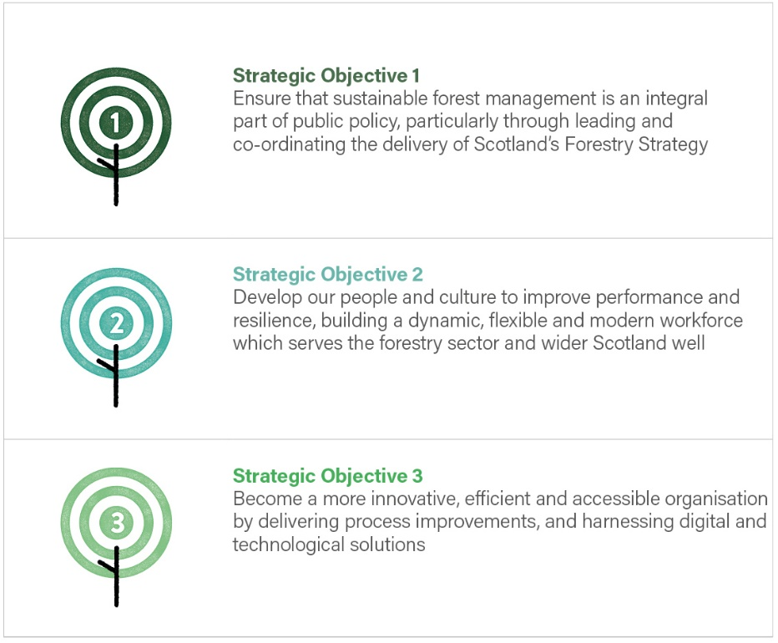

Records underpin our organisation’s policy development and decision-making processes. Our information must be managed effectively and safely from inception to disposal, providing a transparent and accountable trail. Effective records management makes access to our information quicker and easier, improves our business systems, contributes to better service delivery and enables our corporate memory. It increases our opportunities both for remote working and for collaboration across the organisation. Effective records management assists in managing risk and provides continuity during adversity or disaster.

**5. Statutory Obligations**

Effective records management helps us to meet our statutory obligations and responsibilities as an Agency of the Scottish Government, and is critical in protecting the rights of employees and stakeholders.

* The **Public Records (Scotland) Act 2011** sets out a scheme for record-keeping across the Scottish public sector. This policy is one of the requirements of this Act, and should be read alongside our Records Management Plan.
* The **Data Protection Act 2012 (DPA)** and **GDPR** requires our organisation and employees to consider and justify the use of personal data of named individuals. Personal information must not be kept longer than necessary. Good records management will enable our organisation to know which personal information we hold, and that we have permission to hold it. It will ensure it is classified accordingly and kept secure. The information held will be accurate and up to date, and kept for a minimum retention period.
* The **Freedom of Information (Scotland) Act 2002 (FOISA)** and **Environmental Information (Scotland) Regulations 2004** enable the public to access information held by the Scottish Government and its agencies. Effective records management will assist us in locating and releasing all relevant records. By ensuring defunct records are deleted on a systematic and regular basis, only current and pertinent records will be shared. FOISA also requires that we maintain a publication scheme, setting out the types of information we routinely make available. Good records management will enable us to provide this more effectively.
* **Re-use of Public Sector Information Regulations 2015** make it mandatory to make information available for re-use, aiming for economic, social and civil benefits. We must publish an information asset list of information we produce, hold or disseminate that is of interest or value itself and potentially to re-users, and effective records and information management will be essential in producing this asset list.
* **INSPIRE Scotland 2009** requires us to create full metadata for spatial data sets and data services, which will require comprehensive information and records management.

**6. Links to other Scottish Forestry Policies**

This policy forms part of a number of linked policies and procedures concerning the management and security of our information and records which can be found [here](http://saltire/my-workplace/Pages/My-Workplace.aspx#/IT%20and%20information%20management).

**7. Governance, Roles and Responsibilities**

Records management sits within the following governance structure. Certain named staff members have specific responsibilities.

|  |  |
| --- | --- |
| **Governance Structure** | **Accountable Roles** |
| The Chief Executive is supported by the **Scottish Forestry Strategic Advisory Group**, which comprises all Function Heads. three Non-Executives Advisors and the Chief Forester. The Group’s role is to support and provide advice to the Chief Executive in order that they can reach robust and well informed decisions. | The senior individual who has overall strategic responsibility for records management is David Signorini, SF **Chief Executive Officer** (CEO) and Accountable Officer. |
| The **Senior Executive Team (SET)** comprises all Function Heads. The role of the SET is to lead SF and oversee the day-to-day management and direction of the agency. | The **Data Protection Officer** is tasked with monitoring compliance with the GDPR and other data protection laws, our data protection policies, awareness-raising, training, and audits. Under the MOU with Scottish Ministers, the Scottish Government DPO role covers Scottish Forestry. Marliese Richmond, Corporate Planning and Governance Managers is the lead contact on Data Protection. |
| The **Audit and Assurance Committee** comprises the three Non-Executives. The Chief Executive and Head of Finance and Business Services routinely attend along with representatives from Internal Audit and Audit Scotland. They support the Chief Executive by providing advice and constructive challenge particularly around risk management, performance, control, governance and associated assurance to support year-end accountability and reporting. | The **Data Protection Contact Officer** liaises with the Scottish Government Data Protection Unit to keep up to date on data protection issues and carry out any work on ongoing basis. Marliese Richmond, Corporate Planning and Governance Managers is the lead contact on Data Protection. |
| The Forestry and Land Scotland (FLS) Security & Information Risk Assurance Board (SIRAB) considers business risk in relation to business requirement, technological capabilities, current threat landscape, critical assets and legislative requirements. | As FLS provide SF with Digital Services support, SF have a nominated staff member who sits on this group. |
| Information Governance Steering Group | SF intends to create an Information Governance Steering Group to provide assurance, advice and guidance to the above groups and ensure this policy and associated policies are being implemented across the organisation. |

**8. Commitments to Corporate Record-Keeping and Information Management Systems**

Based on the principles laid out in Section 3, we have made the following commitments in relation to our corporate record-keeping systems.

* **Accessible Information -** Our information will be accessible and will meet any statutory duties to make information available (such as Freedom of Information requests and the Open Data Strategy), unless there is a legislative requirement to protect specific information. It will be stored in a way which makes it easy to find.
* **Transparent Decision-Making** – We aspire to ensure our records of decision-making relating to corporate record-keeping and actions to be complete, accurate and accessible to those who may reasonably require them.
* **Employee Responsibility for Records Management** - Each employee is personally and individually responsible for the management of the information they create, use or share and for protecting and storing and disposing this information safely at the right time. Staff are trained to carry out this responsibility.
* **Retention Schedules Implemented** – Our retention schedules set out the recommended periods for which particular classes of records should be retained in accordance with our legal, audit and operational requirements. At the end of that period, the records will either be destroyed or transferred for permanent preservation.
* **Electronic Records Management -** SF uses a range of electronic records management systems (RP&S, Casebook, Geostore, eFIN and eRDM). Scottish Forestry is committed to using electronic document and records management systems. All applicable records from the legacy shared drives will be transferred to electronic files. This will enable us to capture and manage the key events in a record’s lifecycle: creation; access; editing; disposal; and preservation.
* **Review Legacy Information** – Legacy information assets held by SF will be audited, maintained, retrieved and destroyed or preserved in accordance with our business need, statutory and legislative requirements. Where applicable legacy records will be moved to the appropriate electronic records management systems.
* **Manage Paper-Based Records** – Paper-based records will be subject to the same management procedures as electronic data.
* **Knowledgeable Staff -** All staff will undertake relevant training.
* **Resourcing -**  SF recognises the importance of allocating the required time and resources required to enable staff to practise safe and effective records management.

We recognise that in meeting these commitments, there will be considerable benefits at an organisational level. These include:

* Assurance that we are compliant with relevant legislation
* Less staff time spent retrieving documents
* Improved collaboration and workflows
* Increased availability of office space as paper records are phased out
* Important information will be safeguarded which will enable better decision making
* Enabling an increase in flexible working
* Preserves corporate memory

**9. Guidance Documents and Training**

All staff will be supported in training and guidance to use the appropriate systems in their relevant area.

Prior to the use of the Scottish Government Scots network, all staff must be [trained in the use of eRDM](http://saltire/my-workplace/it-and-information-management/it-services/Pages/eRDM-Scottish-Forestry.aspx) before you can access the system. This online training is available on an ongoing basis, enabling you to refresh your knowledge on issues such as document creation, capture/storage of information, retention and disposal.

You are expected to complete online training available on [i-Learn](https://forestry.learningpool.com/login/index.php).

* Managing Information as an Asset
* Protecting and Sharing Information
* Understanding GDPR
* Guide to GDPR

These courses are always available if you wish to refresh your training.

**10. Implementation and Review**

This policy will implemented primarily through our Records Management Plan and supported through guidance, training and oversight by those with designated roles. It will be monitored on a regular basis with input from the Audit and Assurance Committee. The accountable officer will have oversight of activities.

28.10.20